Google Sites Transition Portfolio How-To Guide

The Google Sites Transition Portfolio How-To Guide

2022

A publication of the Indiana Secondary Transition Resource Center (INSTRC),
a project of the
Center on Community Living and Careers
Indiana Institute on Disability and Community
Indiana University

www.instrc.indiana.edu

The Center on Community Living and Careers is one of seven centers at the Indiana Institute on Disability and Community addressing issues across the lifespan. By promoting partnerships between Indiana schools, state agencies, and other support organizations and through its research, education, and service, CCLC is committed to bringing positive change to people with disabilities as they work and participate in their communities.

Copyright © 2022, Center on Community Living and Careers

With funding from the Indiana Department of Education, Office of Special Education

The Indiana Transition IEP Rubric

2018-2019

A publication of the Indiana Secondary Transition Resource Center,
a project of the
Center on Community Living and Careers
Indiana Institute on Disability and Community
Indiana University.

www.instrc.indiana.edu

The Center on Community Living and Careers is one of six centers at the Indiana Institute on Disability and Community addressing issues across the lifespan. By promoting partnerships between Indiana schools, state agencies, and other support organizations and through its research, education, and service, CCLC is committed to bringing positive change to people with disabilities as they work and participate in their communities.

Copyright © 2018, Center on Community Living and Careers.

With funding from the Indiana Department of Education, Office of Special Education.

How to Use This Guide

Google Sites Transition Portfolio How-To Guide
This guide is meant to assist teachers, counselors, Pre-ETS (Pre-vocational Employment Transition Services) providers, and other student supporters in helping a student set-up, create, and edit their transition portfolios using the Google Sites template. Transition portfolios are a required component for any student completing a Certificate of Completion course of study beginning with students exiting high school in 2023. Beginning with that 2023 cohort, the portfolio can be started as early as the 6th grade; however, it is required in the year that the student turns 14 or enters 9th grade, whichever comes first. Transition portfolios may be used to demonstrate employability skills to satisfy the requirement for Graduation Pathways.

Included in this guide:
- How to make a copy of the Google Sites template for your own use
- How to edit each section of the transition portfolio
- How to upload documents or other items into the site
- How to use the other tools within Google Sites

The guide is not meant to inform a one-size-fits-all end-product. Rather, the guide is intended to assist you in navigating Google Sites features from which a portfolio can then be tailored for each student. Transition portfolios need to be student-centered. The Google Sites template outline will be similar or the same for all students because all student transition portfolios will contain information across the same four broad domains, or components: Student Information, Student Learning Characteristics, Academic Skills, and Employability Skills. Despite that similarity, each student will use individually created documents, videos, or other information from which to build component content. Wide berth is given for students to create informative artifacts based on their postsecondary goals and plans.
After reading this guide, please feel free to reach out should you have additional questions. You may contact a member of the INSTRC team.
Please contact:
INSTRC@indiana.edu

How to Make a Copy of the Google Sites Template
The first step in creating a copy of the Google Sites template begins with logging onto your Google account. A Google account is necessary to make a copy of the transition portfolio template. You must make a copy of the template before you begin, otherwise you will ruin the template and others’ use of the blank document. If you do not currently have a Google account, you will need to create one. Please refer to instructions and screenshots below. You may choose to use the following link for step-by-step instructions for creating a Google account as well as a Gmail email account: https://edu.gcfglobal.org/en/googleaccount/creating-a-google-account/1/

Using the link provided, follow the on-screen prompts. Included below are a series of screen illustrations guiding a user through the Google account set-up process. Please note students will need to eventually use their personal Google accounts to be able to access their portfolios once they have exited school. Student school emails or a teacher’s email will not be long-term and accessible storage options for the student. Teachers may need to collaborate with parents or other student supporters to ensure each student has a personal Google account prior to leaving school.
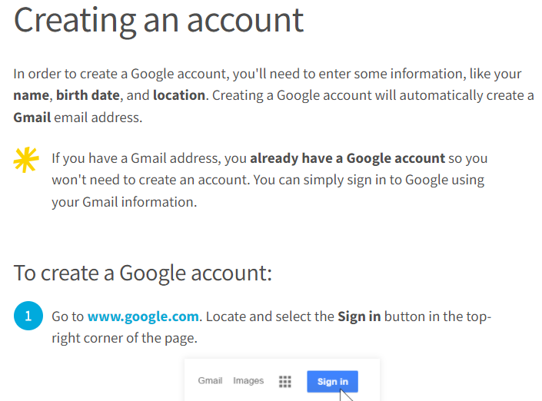

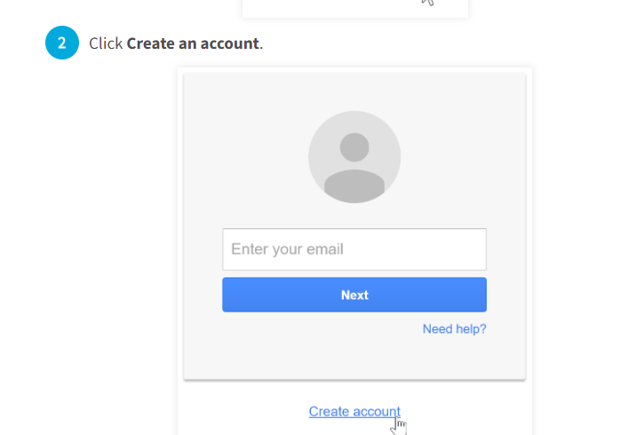

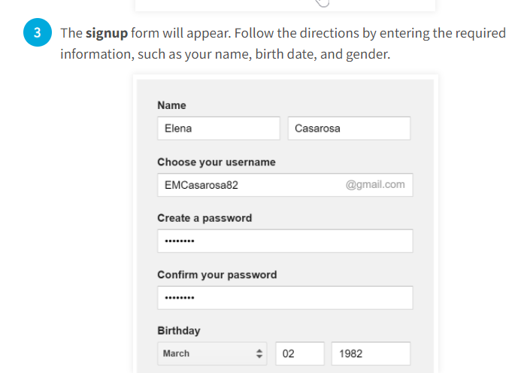

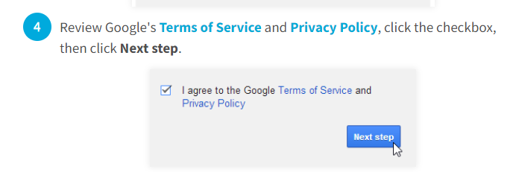

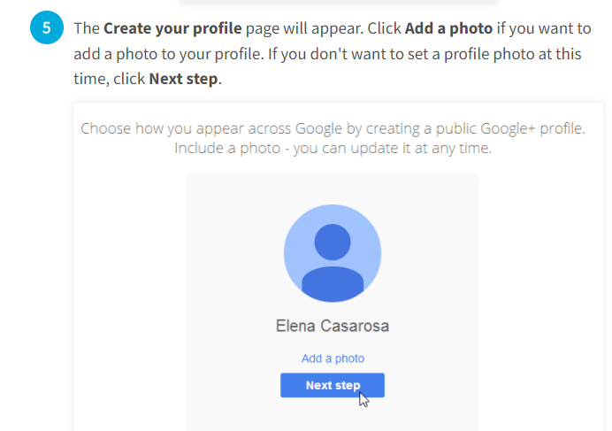

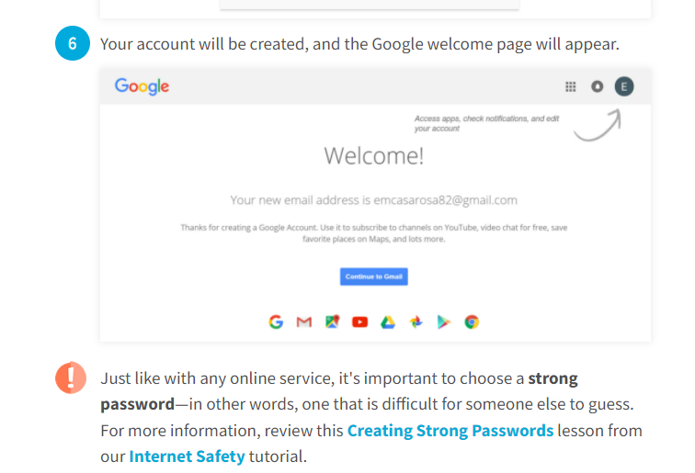

Open and Copy the Google Sites Template
The next step, after creating a Google account, is to open the Google Sites Template.
Once opened, you will see the Google Sites template displayed. That display is illustrated below.
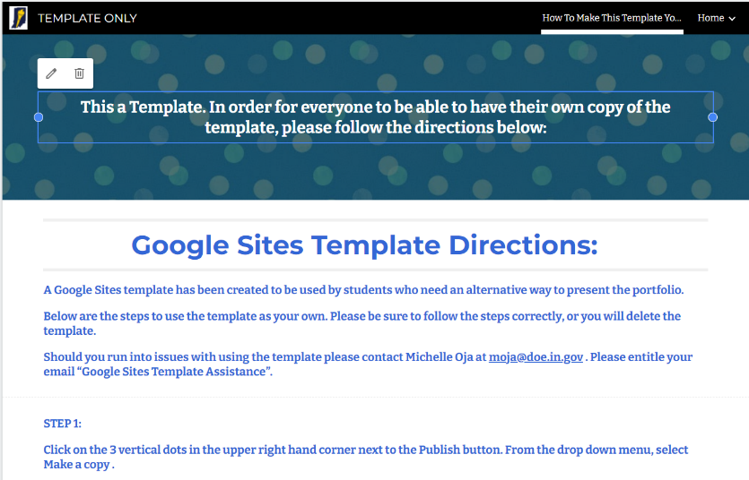

Next, find the three vertical dots at the top of the template page:
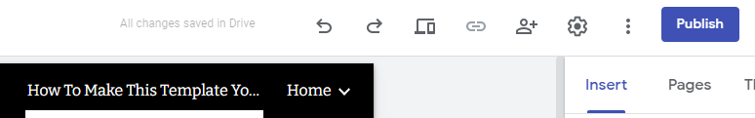

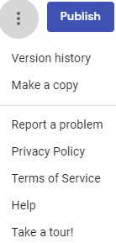
Click on those vertical dots and a drop-down menu will appear. Select “Make a Copy”.

A new screen will appear (pictured below). Type in the title of the portfolio you are saving and ensure the ‘Entire site’ circle button is displayed (clicked) in blue. Select a title for each copy of the portfolio to uniquely identify the student’s name. When finished, click the ‘OK’ button.

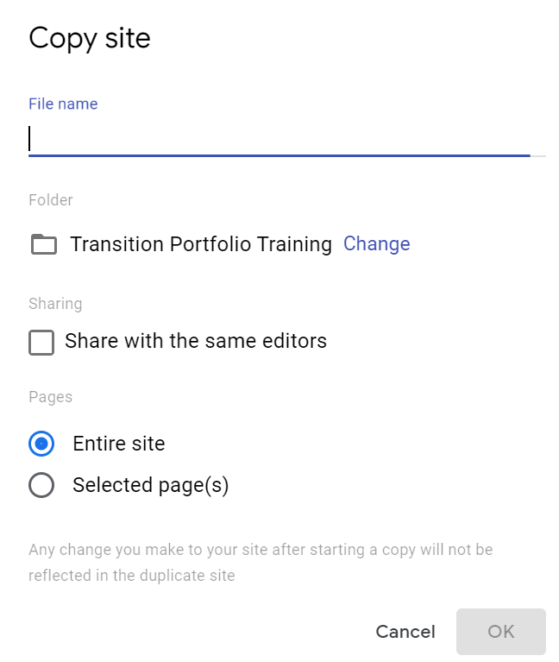
Once you have titled the copy as desired, be sure to record the website address so that others will later be able to see the portfolio in its completed form. You are now ready to begin completing the portfolio.

Features of the Google Sites Portfolio
Features and Pages of the Google Sites portfolio are reviewed below. In addition, the Indiana Department of Education has created a short instructional video highlighting and explaining many Google Sites portfolio features. We encourage you to review this document in its entirety. Many educators may prefer to “save a copy” of the Google Sites template for practice purposes before beginning to create a student portfolio. Practicing will allow you to become familiar with each feature.

Google Sites Portfolio Pages
There are five pages to each student portfolio. Except for the Homepage, every other page contains subpages. The Homepage has pre-assembled text boxes in which a student may enter his/her name, address, and email as well as other information as desired. The portfolio pages are:
- Home
- About Me
- Hobbies
- Preferences
- Interests
- My Assistive Technology
- My Activities Resume
- Learning Characteristics
- How I Learn Best
- Communication Skills
- Social Skills
- Skills and Strengths
- Challenges/Needs
- Academic Skills
- Transcript
- Academic Achievements
- Employability Skills
- Workplace Needs
- Work Experiences
- My Resume
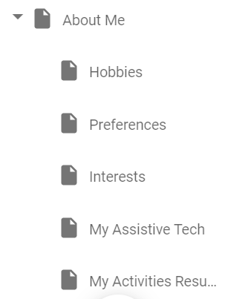
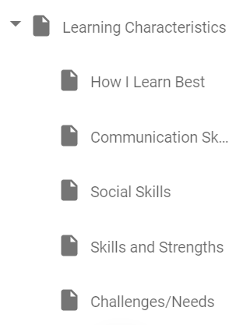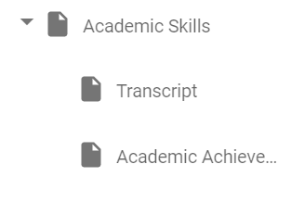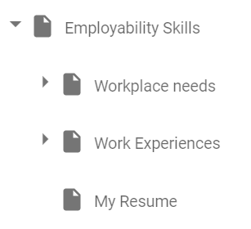

The Google Sites template comes to you already formatted and organized with specific pages aligning to required portfolio components. This makes the task of portfolio creation simpler. Each of the other pages and subpages have their own banners (top section of each page and subpage) where you can edit the text and the background image. The list of portfolio pages can be found by clicking “Pages” along the top ribbon to the right of the portfolio display:
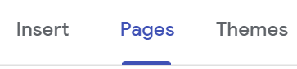
Follow the organizational structure of each page and begin building content by placing artifacts into the portfolio where it is appropriate. Artifacts can include standardized assessments, authentic assessments, pictures, videos, descriptive documentation; the possibilities are endless. Each artifact will illustrate, clarify, support, or describe categories within each page and subpage.
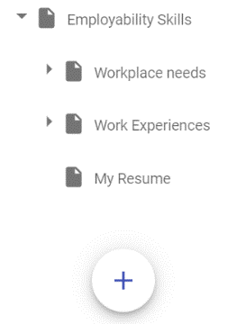
If you or the student wishes to add more pages, simply select the “+” button at the bottom of the pages list. Be sure you are in the section you wish to add a page to before pressing the add button. If you make a mistake, you are able to drag and drop the new page into the correct part of the template. To delete a page, hover until three vertical dots appear to the right of the page. Click on the three dots and select delete from the dropdown menu.

Google Sites Features
To the right of the portfolio pages, you will find navigation options. These options are: Insert, Pages, and Themes.
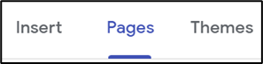

The Insert Tab
The Insert tab will have most of the features you will use in creating an individualized student portfolio. These features include options for adding text, images, documents, and web links. The insert tab also features options for adding certain layouts for each page, depending upon your aesthetic preference. Layouts can make a page visually appealing and can organize content well. Other options available from the Insert tab include:
- Collapsible group
- Table of contents
- Image carousel
- Button
- Divider
- Placeholder
- YouTube
- Calendar
- Map
- Docs
- Slides
- Sheets
- Forms
- Charts
The Insert tab makes several options available through which to place artifact content into a chosen portfolio page. At the top of the Insert feature you will find: Text box, Images, Embed, and Drive. Selecting (clicking) the “Text box” button will produce a text box into the page you are currently navigated upon. The text box will look like this:
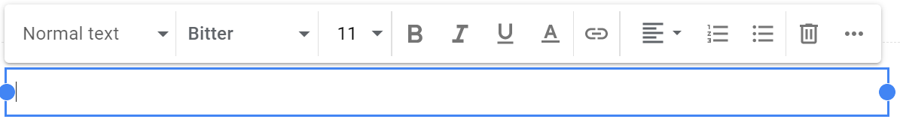
Once you have placed a text box onto a portfolio page, you can begin to enter information desired into that text box. Within the text box, as you can see, you are able to select font heading, font style, font size, choose to bold text, choose to place text in italics, underline text, select text color, place a link in the text box, position text, add numbers or bullets, and more (select the more options by clicking on the three horizontal dots to the far right of the text box). If you decide you do not want that text box, simply click the trash can icon. The size of the text box can be manipulated by using the two blue dots (drag them) inward and outward.

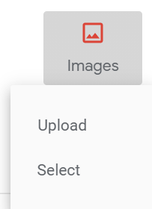
The “Images” button allows you to either “Upload” or “Select” images. When you click on “Upload”, a pop-up screen will appear which will allow you to navigate through your computer files to select the image you want to include. Images can be placed into the portfolio either from your computer files or from your Google Drive files. The upload option should be used when an image is saved to your local computer. For example, you might have a picture folder on your desktop and from within that folder you wish to place several pictures onto a portfolio page. If this is the case, the upload option should be used. The select option should be used when an image is saved to the Google Drive, or from the internet. Using (clicking) the select option will produce this screen:
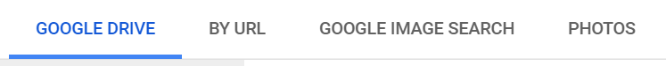
Proceed by using your Google Drive images, using an image’s URL, searching for an image in Google Image, or select a photo saved to your Google Drive. When you click on “Select”, a pop-up screen will appear which will allow you to copy and paste a URL from a previous search, search for an image using the Google search engine, or select images you’ve put into your Google Drive. When you click on the From Drive icon, a sidebar appears with the options of selecting content from My Drive, Shared Drives, Shared with Me, or Recent (not pictured). First click on the location you wish to get your information from, then find the content, select the content, and click on the blue insert bar to add the content to the page.
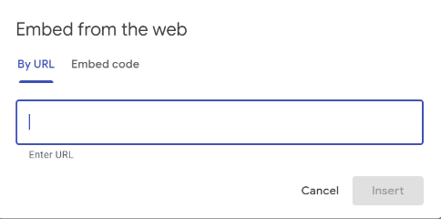
The “Embed” button allows you to embed a webpage link or video. This might be especially helpful if a student has created a video demonstrating use of particular skill sets and saved that video in YouTube. One might also embed a career-related video a student has watched as they were learning more about particular or potential careers of interest. The student can easily embed a link, and next to that link, add a text box with a descriptive narrative of what they learned or otherwise describe why the artifact was used.

The “Drive” button allows you to place any document saved in your Google Drive onto any chosen portfolio page or subpage. When selected, Drive will pull up all documents. Simply click the document you desire and select “INSERT” at the bottom of the screen.

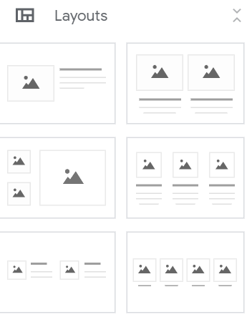
Following those options (also from the Insert tab) you will find available “Layouts” for use in the page or subpage of your choosing. The layouts provide you with an organizational option. Each layout includes a graphic organization of artifact content using a combination of text and uploads. By selecting (clicking) a layout type, that layout is automatically placed into the page or subpage. From that point, you add content into that layout.

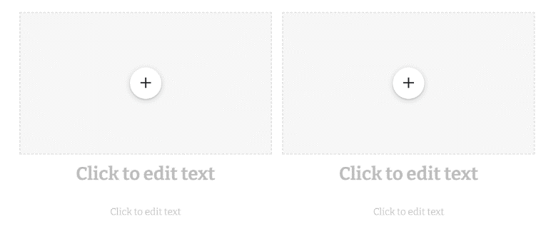
Once selected, a layout will be placed on the page or subpage from which you are working. The image of this display is illustrated by the screen shot to the right.

Within each display, you may enter text as desired in the “Click to edit text” header and sub-headers. You may also click the button to add content.

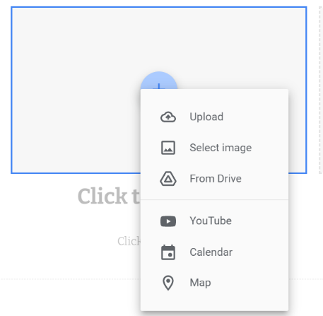
When you select this button to add content, several options appear. Those options allow you to:
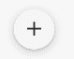
- Upload
- Select image
- From Drive
- YouTube
- Calendar
- Map

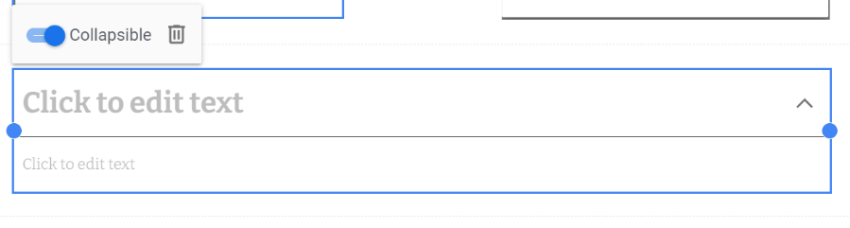
The Collapsible group button allows you to place text onto the pages or sub-pages as desired. Collapsible group can help to condense larger sets of information or larger lists. Clicking the caret to the right of the header text will expand (or make visible) the content below that header text. This might be a good way, for example, to list the many soft skills a student has.
The Table of Contents button can add structure to your document and help readers find what they’re looking for. Creating a Table of Contents requires the following steps:
- Use headings. Click the Styles menu and select a heading.
- Once you create a heading style for each section, click where you want the table of contents to go. Click Insert.
- Hover the mouse over Table of Contents. Select a layout style. One layout has blue links, while the other shows page numbers. However, they both work the same way.
- Use the toolbar to edit and format the text as you please.
- If you’d like to go to a particular section, click it and then click the link in the box.
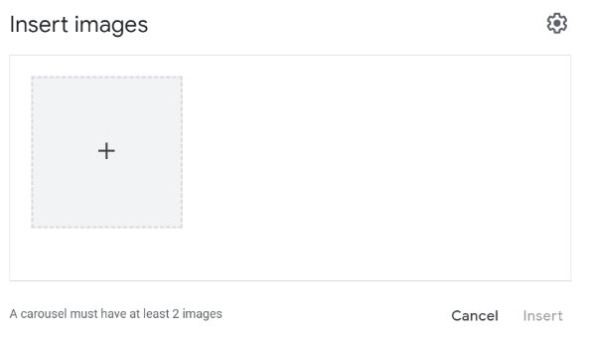
The Image Carousel button may be used if a student has multiple images from a singular activity or event. The image carousel may be a better option to include these images or pictures instead of uploading each individually. The Image Carousel tool allows viewers to scroll through multiple added images. The same options to add images are available as uploading them one at a time. Keep in mind an Image Carousel must have at least two (2) images.

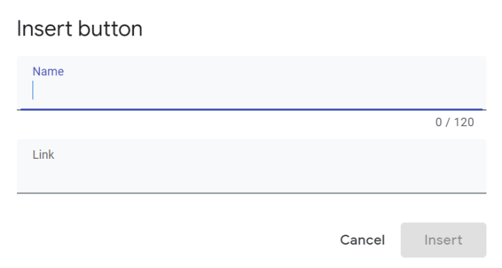
The Button is an object on a slide that performs an action when clicked or pointed to, such as jumping to another slide or playing a sound. Action buttons are most commonly used for self-running presentations – for example, presentations that are presented at a booth or kiosk. Action buttons are not the same as hyperlinks. You may find more information about using buttons while in Google Sites.

The Divider button simply provides a visual and decorative line break between information on any given page or sub-page. A divider helps to have a visual division of the content into groups on the screen. Google Sites supports the feature of dividers which helps you to separate the content and show them more adequately.
The Placeholder button is an image placeholder, or a dummy image, designed to draw attention to the need for an actual image. You might use the placeholder, for example, if you want a particular planned-for image to be placed on a particular page, but do not yet have the image saved to your computer files or your Google Drive.
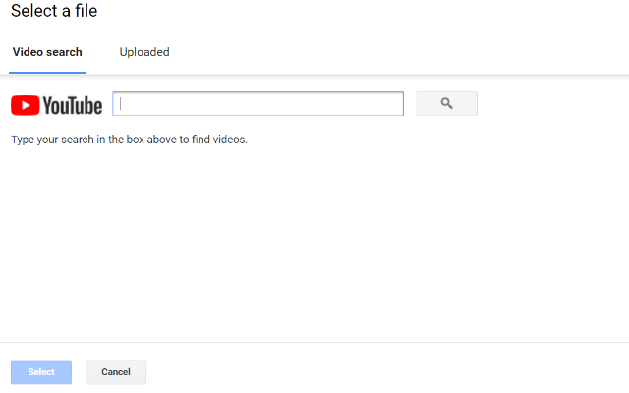
The YouTube button allows for upload of a YouTube video. Students may want to include videos of themselves at worksites. If this is the case, a student may need assistance from others to film the video and upload it to YouTube (for subsequent upload to the portfolio). Students may want to display career videos they have watched as an indication of their interest in a particular career pathway or specific job.

The Calendar button may be used to illustrate any desired weekly, monthly, or yearly appointments/schedules. In terms of being a portfolio artifact, the calendar option might illustrate a student’s work ethic (employability skills) or organizational ability (employability skills).
The Map button may be used to illustrate the locations of certain places or routes. In terms of being a portfolio artifact, the Map might be combined with a descriptive narrative to demonstrate hobbies or interests (Student Information), combined with descriptive documentation to demonstrate business location from a Volunteer Summary Log form, or combined with descriptive documentation to demonstrate location of volunteer or work site experience.
The Docs, Slides, Sheets, Forms, and Charts buttons allow you to easily access and insert any of those document types already saved in your Google Drive.

The Pages Tab
The Pages tab, when selected (clicked), will produce a list of portfolio pages and subpages already built into the portfolio template for your use. Refer to the images on page 9 of this document. The pages and subpages are listed vertically in the component order they appear in the portfolio. Clicking the caret next to each page display will produce the list of subpages belonging to each component page.

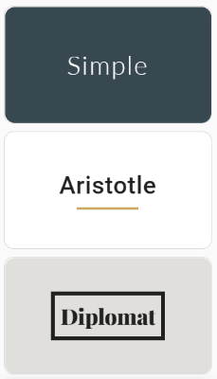
The Themes Tab
The Themes tab, when selected (clicked) allows you to choose the look and feel of text on any given page. Each page, in fact, can have a different theme if you prefer. Pre-made themes include Simple, Aristotle, Diplomat, Vision, Level, and Impression. Each theme looks unique. You do not have to choose a theme from this list, but they are available should you like to.

Appendix: Resources
Authentic Assessment: A Blueprint for Quality Transition
https://www.youtube.com/watch?v=d48vGvmW5xw&feature=youtu.be

Transition Resource Collections (e.g., health, career videos, for educators new to transition)
https://instrc.indiana.edu/resource-collections/index.html

Sample IEPs
https://instrc.indiana.edu/resource-collections/sample-ieps.html

Transition Assessment Matrix
https://instrc.indiana.edu/transition-resources/transition-matrix.html

Using Authentic Assessment for Age-Appropriate Transition Assessments
https://www.youtube.com/watch?v=QE5paAqQNQA&feature=youtu.be

Writing Quality IEPs
https://instrc.indiana.edu/resource-collections/writing-ieps.html

2020 Transition IEP Training: Building Bridges to Quality-Transition IEP
https://www.youtube.com/watch?v=XfJWte0YZ_0
Transition IEP Mini-Series
https://expand.iu.edu/browse/iidc/instrc/programs/transition-iep-miniseries
Transition Services and Activities: Making the Connection
https://instrc.indiana.edu/pdf/resources/TransitionServicesandAcvititiesMakingtheConnection.pdf

instrc.indiana.edu

instrc.indiana.edu

2810 E Discovery Parkway Bloomington, IN 47408
812-855-6508

1905 N. Range Rd.
Bloomington, IN 47408
812-855-6508

A publication of

A publication of

